SRI DNR GDC [W], PALAKOL.
ACTIVITY : RICE DONATION ON 05-07-2022
OBJECTIVES :To improve the helping nature and as well as to increase the thought of social responsibilities of the students towards the society.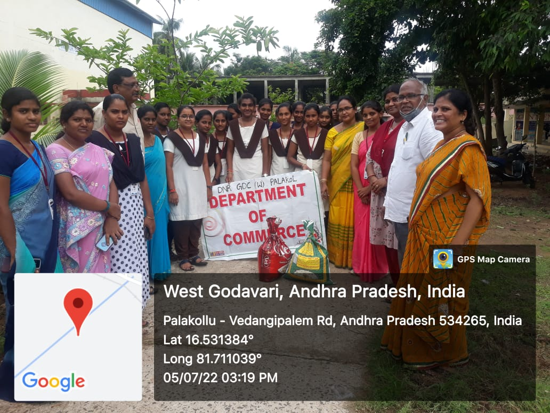
DESCRIPTION :Old orphanages are for the people who have lost their families and are cared for.Helping old aged & poor people who are living in orphanage.
We donated rice for “RAHUL SOCIAL SERVICE SOCIETY-OLD AGE HOME ” located beside reliance petrol bunk, palakol-narsapur road ,palakol .
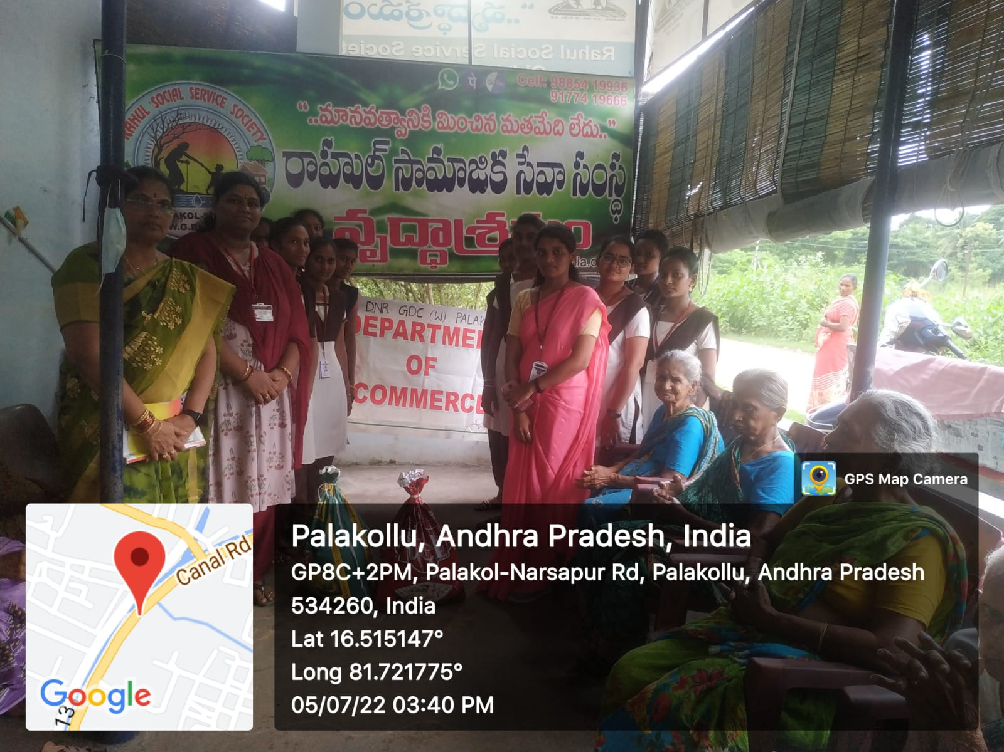
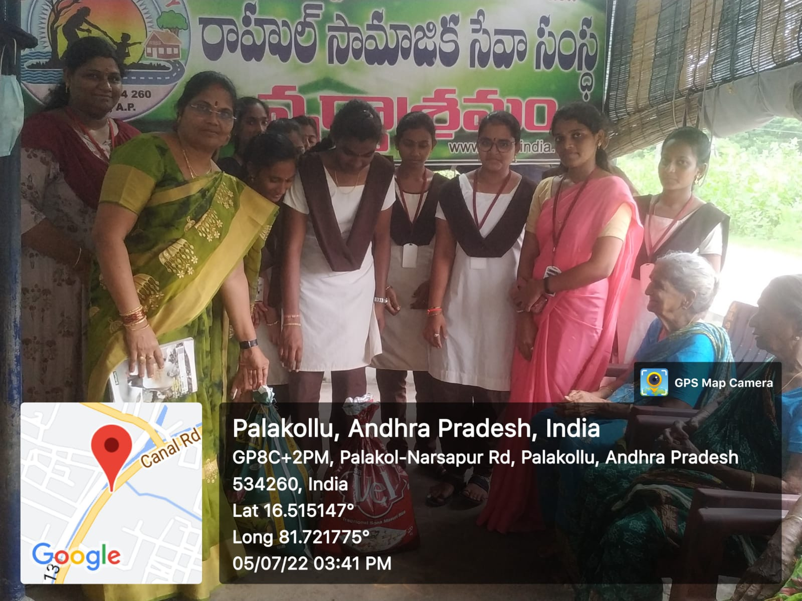

OUTCOME :To Encourage The Students For Helping And To Improve Their Kindness Towards The Society .By This Students Learnt To Serve And Help The People In The Society Who Needs Help .
NO. OF STUDENTS PARTICIPATED: 24
NO. OF LECTURERS PARTICIPATED : 2

